Jada Thibodeaux
February 21, 2021
Professor Nieland
DAD 220

I learned that Massachusetts has had 988 returns of the BAS-08-1 C. Following that, Arkansas is second with 858 returns of the ENT-48-40F and West Virginia is third with 851 returns of the ENT-48-40F.
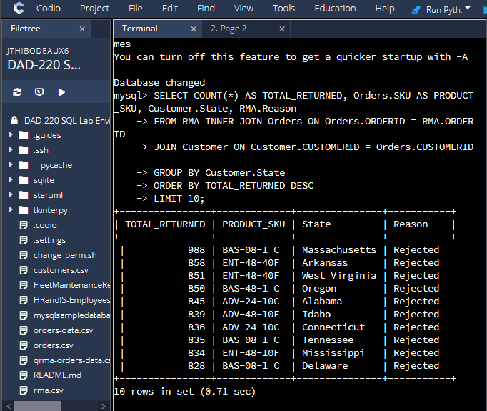

The most refunded item is the BAS-48-1 C at 8422 returns, the ENT-48-40F at 6213 returns, and the ENT-48-10F at 4345 returns.
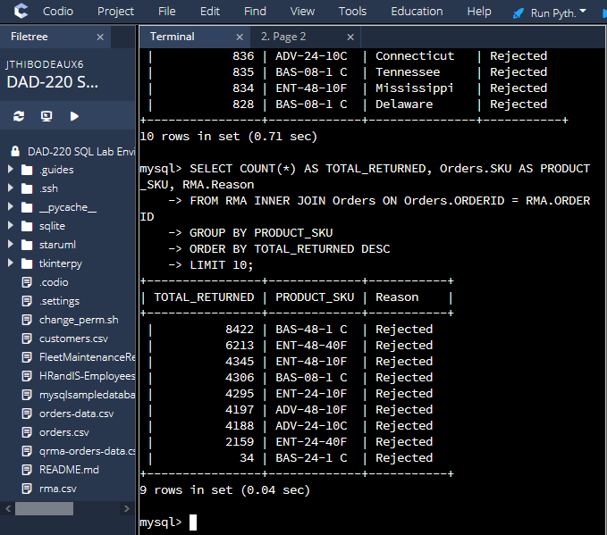

90% of the products returned were for replacement or refund which shows there may be a problem with manufacturing or quality and management
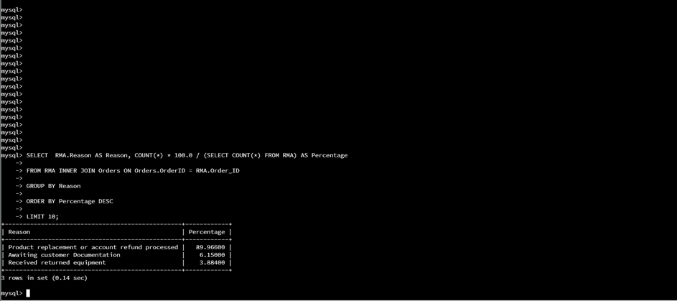

The percentage of returns shows the number one returned item in Massachusetts is 6th in the nation. This may suggest that there is a problem with shipping since its not congruent with the items returned nationwide. Massachusetts is a very hazardous area in the northeast so things such as bumpy roads should be accounted for
